## **USER ADOPTION DASHBOARD**

# **Snowsight Dashboard Setup**

## 1. Create a Dashboard

Login to the account and navigate to the **tab dashboard** in the left side options ,then click on the **+dashboard** option highlighted in blue to create a new dashboard.

## 2. Name the dashboard

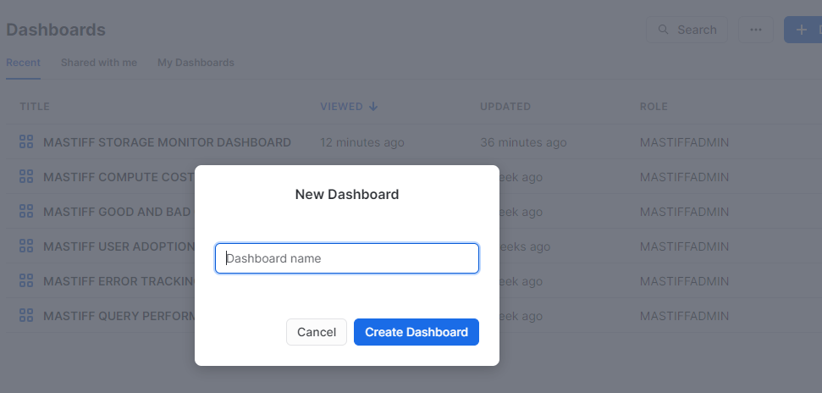

Next step is to give an appropriate name to the dashboard and click **Create Dashboard**.

## 3. Setup the Role and Warehouse

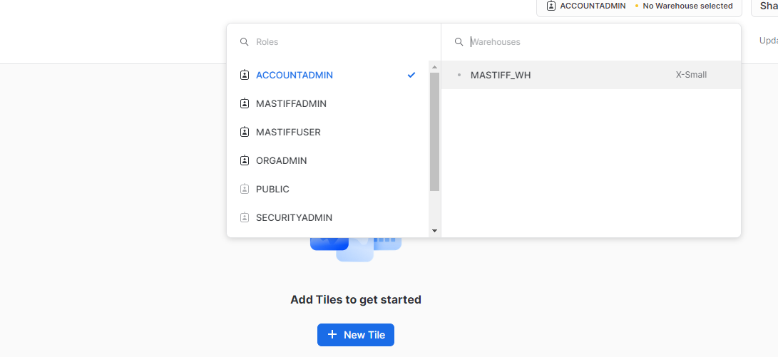

## 4. Creating KPIs and Charts

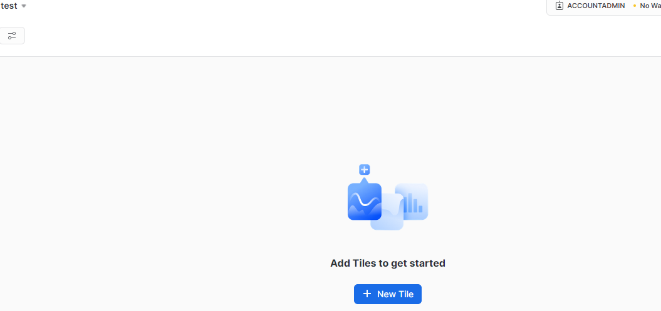

To create KPIs and charts, start by adding a new tile by clicking **+New Tile .**

## 5. Adding names to the KPIs and Executing the queries.

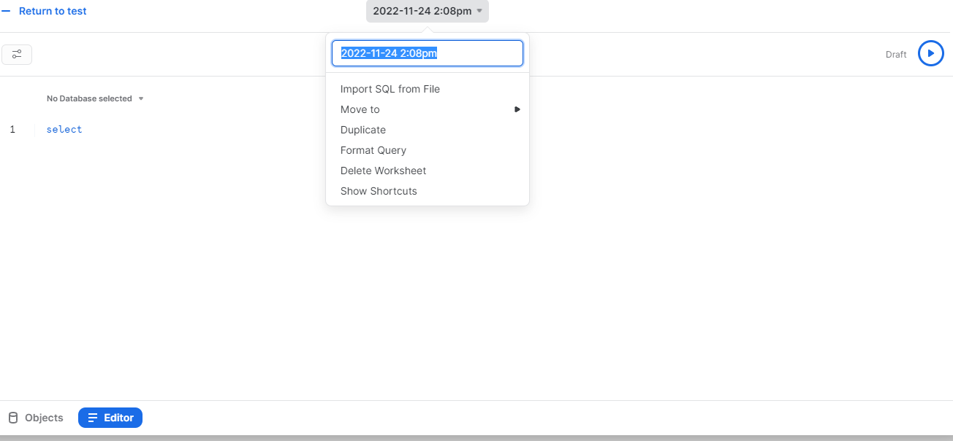

We can name the KPI by clicking the date followed by the time and changing it to the required name. To execute a query, type in the editor and click the run button to get the desired results.

**Note :** Before you create all the dashboards in Snowsight, Use the role **MONITOR_ADMIN** and warehouse **MONITOR_WH** to create dashboards in SNOWSIGHT for Watchkeeper.

## 

## **USER ADOPTION DASHBOARD SETUP**

## **Filters**

**Customize the filter query's refresh frequency to align with your requirements. If you regularly analyze dashboards, consider refreshing it daily for up-to-date data. However, if dashboard analysis is infrequent, opt for "never refresh" to reduce unnecessary costs. Keep in mind that choosing "never refresh" means running filter query manually when utilizing the dashboard, which can be done from the filter section.**

### **Role filter**

**Display Name** :- ROLE

**SQL Keyword** :- ROLENAME

**Role** :- MONITOR_ADMIN

**Warehouse** :- MONITOR_WH

**Options Via** :- Query

**Write Query** :- SELECT DISTINCT(ROLE_NAME) FROM SNOWFLAKE.ACCOUNT_USAGE.QUERY_HISTORY;

Go for the below selections :

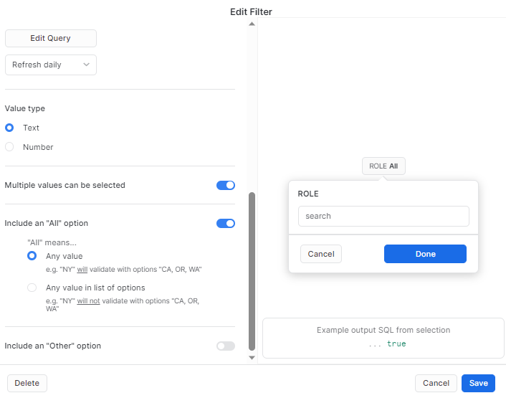

### **Query type**

**Display Name** :- Querytype

**SQL Keyword** :- querytype

**Role** :- MONITOR_ADMIN

**Warehouse** :- MONITOR_WH

**Options Via** :- Query

**Write Query** :- select distinct(query_type) from SNOWFLAKE.ACCOUNT_USAGE.QUERY_HISTORY;

Go for the below selections :

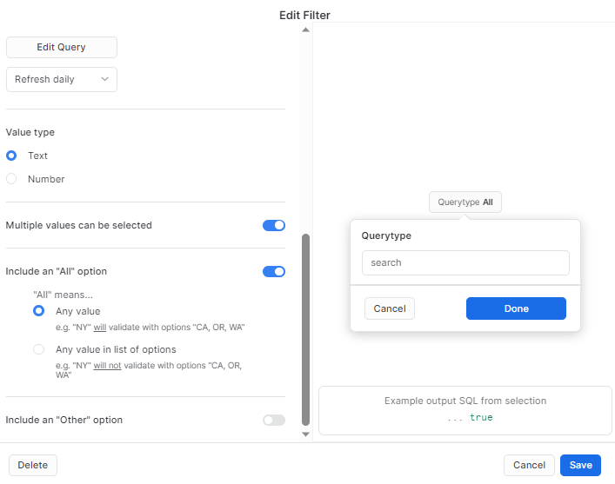

### **Query Tag Filter**

**Display Name** :- Querytag

**SQL Keyword** :- querytag

**Role** :- MONITOR_ADMIN

**Warehouse** :- MONITOR_WH

**Options Via** :- Query

**Write Query** :- select distinct(query_tag) from SNOWFLAKE.ACCOUNT_USAGE.QUERY_HISTORY;

Go for the below selections :

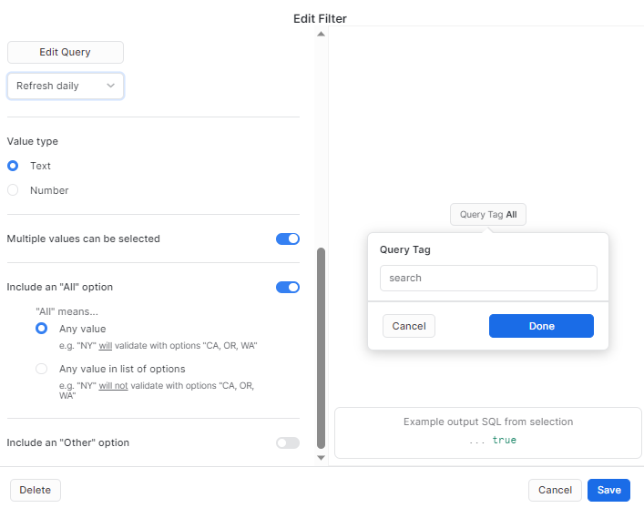

### 

### **1 TOTAL USERS**

select count(distinct(user_name)) from snowflake.account_usage.query_history

where role_name = :ROLENAME and query_type = :querytype and query_tag = :querytag ;

-**Note: This metric encompasses all the users who have executed queries, regardless of their current active status.**

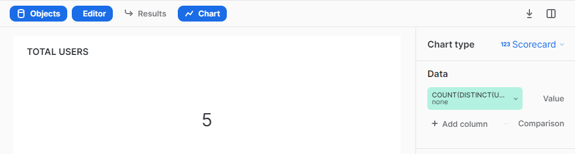

### 

### **2 TOTAL QUERIES**

select count(*) from snowflake.account_usage.query_history where role_name = :ROLENAME and query_type = :querytype and query_tag = :querytag;

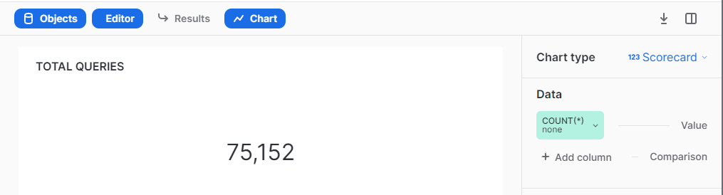

### 

### **3 AVG QUERIES PER USER**

select round(count(*)/(select count(distinct(user_name)) from snowflake.account_usage.query_history where role_name = :ROLENAME and query_type = :querytype and query_tag = :querytag),2) from snowflake.account_usage.query_history where role_name = :ROLENAME and query_type = :querytype

and query_tag = :querytag;

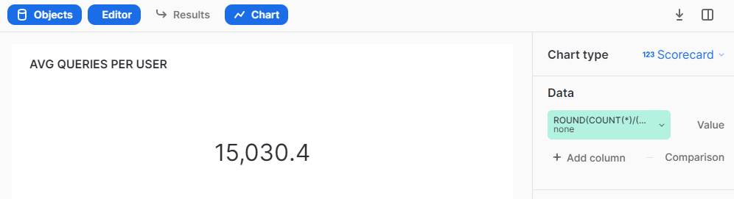

### 

### **4 AVG EXECUTION TIME PER QUERY**

select round(sum(execution_time)/(select count(*) from snowflake.account_usage.query_history

where role_name = :ROLENAME and query_type = :querytype and query_tag = :querytag ),2) from snowflake.account_usage.query_history where role_name = :ROLENAME and query_type = :querytype

and query_tag = :querytag;

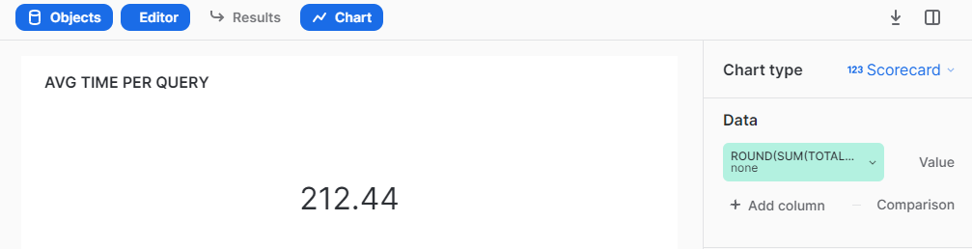

### 

### **5 USERS PER WAREHOUSE**

select distinct(user_name),warehouse_name from snowflake.account_usage.query_history

where role_name = :ROLENAME and query_type = :querytype and query_tag = :querytag;

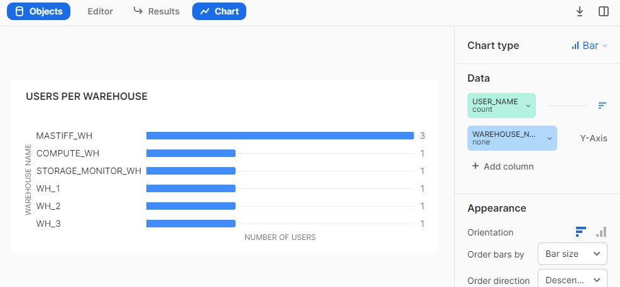

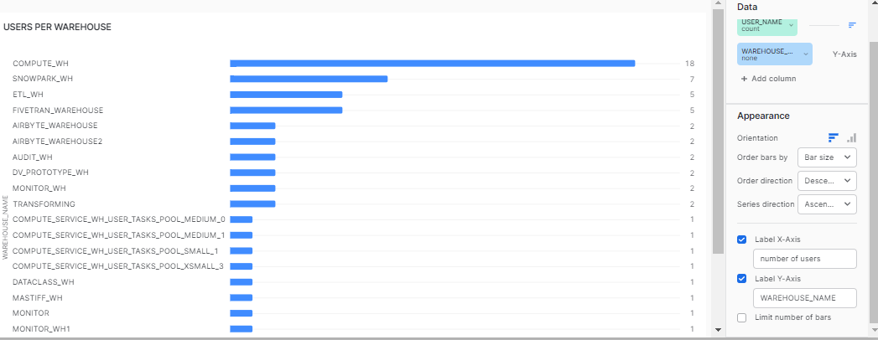

### 

### **6 USERS PER DATABASE**

select distinct(user_name),database_name from snowflake.account_usage.query_history

where role_name = :ROLENAME and query_type = :querytype and query_tag = :querytag;

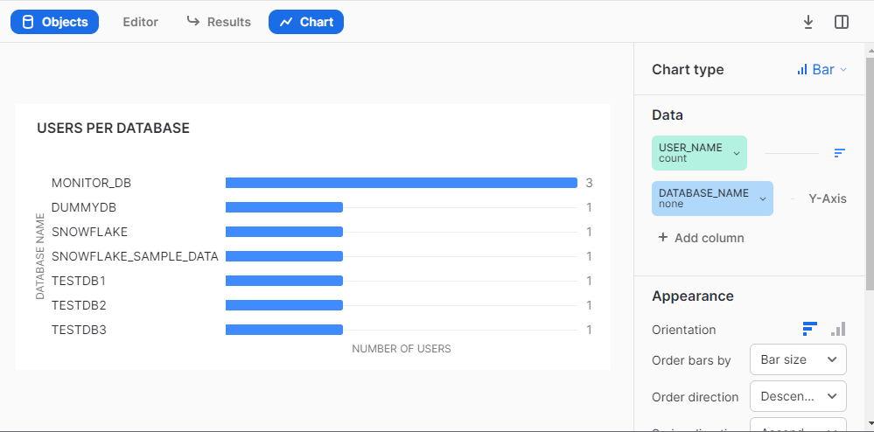

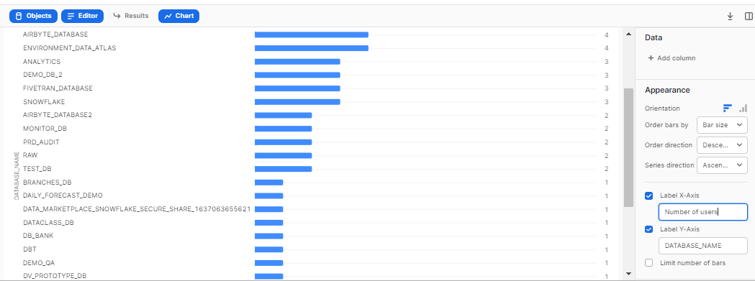

### 

### **7 USERS QUERY USAGE OVER TIME**

select query_id, start_time,user_name from snowflake.account_usage.query_history where role_name = :ROLENAME and query_type = :querytype and query_tag = :querytag;

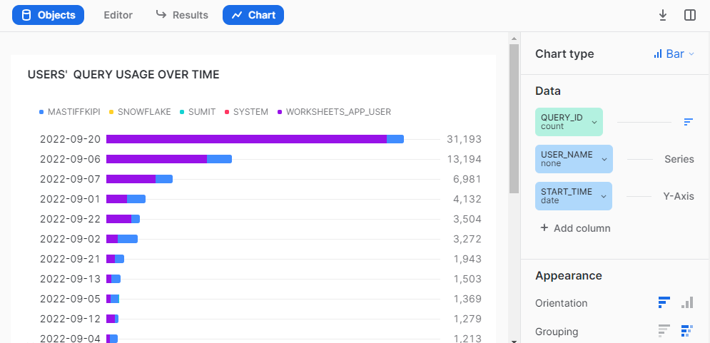

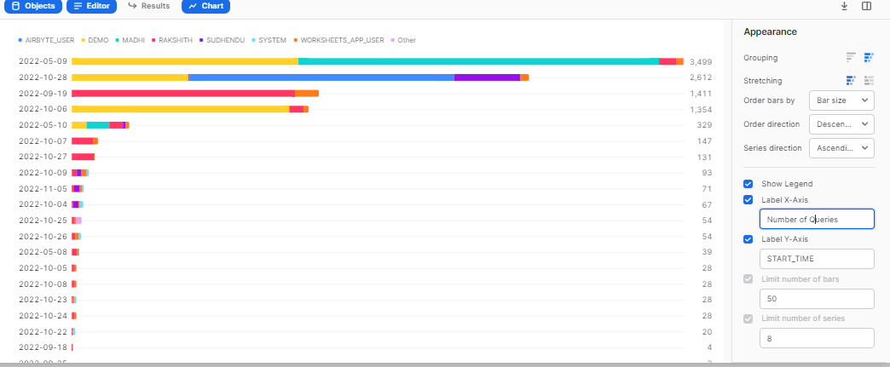

## **Best Practices -**

* If you have records more than 10000 then select only top 9999 ( refer. link:- <https://docs.snowflake.com/en/sql-reference/constructs/top_n.html>) to create a chart as Snowsight only supports data to be visualized till 9999 rows.
* It's preferable to do aggregation in the query itself rather than to do it in Snowsight UI.
* Adjust the round off value as per your requirement ( e.g - round((<column_name>), n) where n = natural number ).
* On hovering over any filter, visuals getting filtered would be highlighted.
* To make filter interaction more user friendly, you can even use color coding.
* Customize the refreshment time of the filter query according to your specific needs.
* If snowsight dashboard is running slow, then to optimize performance:
  + It is recommended to extract only three months (or less than three months) data from the query history using a date range filter in all the KPIs.

For example - select count(*) from snowflake.account_usage.query_history where start_time = :daterange;

* + Utilize a custom table to store the latest three months (or less) of query history data, allowing you to leverage it for the user adoption dashboard.